* [Insert some data into a table](https://pgexercises.com/questions/updates/insert.html)

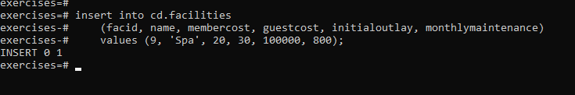

* [Insert multiple rows of data into a table](https://pgexercises.com/questions/updates/insert2.html)

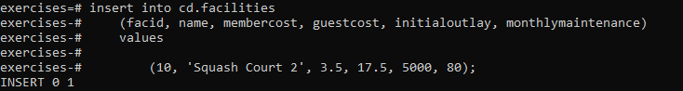

* [Insert calculated data into a table](https://pgexercises.com/questions/updates/insert3.html)

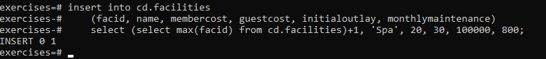

* [Update some existing data](https://pgexercises.com/questions/updates/update.html)

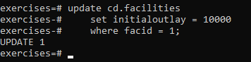

* [Update multiple rows and columns at the same time](https://pgexercises.com/questions/updates/updatemultiple.html)

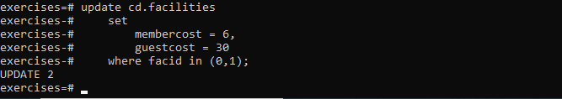

* [Update a row based on the contents of another row](https://pgexercises.com/questions/updates/updatecalculated.html)



* [Delete all bookings](https://pgexercises.com/questions/updates/delete.html)

**delete** **from** cd.bookings;

* [Delete a member from the cd.members table](https://pgexercises.com/questions/updates/deletewh.html)

**delete** **from** cd.members **where** memid = 37;

* [Delete based on a subquery](https://pgexercises.com/questions/updates/deletewh2.html)

**delete** **from** cd.members **where** memid **not** **in** (**select** memid **from** cd.bookings);